Screenshot

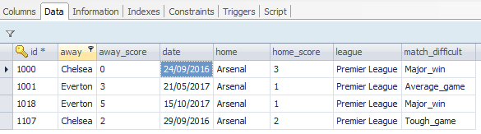

Create table script

|  |
| --- |
| CREATE TABLE `soccer_match` (  `id` **varchar**(**255**) NOT NULL,  `away` **varchar**(**255**) DEFAULT NULL,  `away_score` **varchar**(**255**) DEFAULT NULL,  `date` **varchar**(**255**) DEFAULT NULL,  `home` **varchar**(**255**) DEFAULT NULL,  `home_score` **varchar**(**255**) DEFAULT NULL,  `league` **varchar**(**255**) DEFAULT NULL,  `match_difficult` **varchar**(**255**) DEFAULT NULL,  PRIMARY KEY (`id`)  ) ENGINE=InnoDB DEFAULT CHARSET=utf8; |

* No need to execute because the DB table will be create once the tomcat was started